Field Installation of Nodes and Gateways

This document describes the installation of gateways and nodes in the field. Each Node will have three TDR310S sensors. The cover crop Nodes will also have a Campbell Scientific CS655 installed two inches under the residue decomposition bags to monitor soil water near the soil surface. The cover crop Nodes will also have a temperature and a relative humidity sensor.

|  |  |
| --- | --- |
| **Cover Crop Node** | **Bare Node** |
| 3 – TDR310S sensors with PVC pipe and caps | 3 – TDR310S sensors with PVC pipe and caps |
| 1 – CS655 sensor | 1 – 12V sealed lead acid battery with box |
| 1 – DS18B20 temperature sensor | 1 – 12V solar panel with mount |
| 1 – SHT31-D relative humidity sensors |  |
| 1 – 12V sealed lead acid battery with box |  |
| 1 – 12V solar panel with mount |  |

#### *Supplies*

1. Sensors 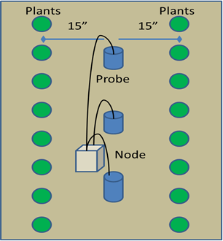
2. 12V SLA battery with battery box
3. 12V solar panel
4. 1-1/4” Flight Auger
5. Wooden dowel 1" diameter
6. Measuring stick or tape
7. Hand trowel and hand hoe
8. Duct seal putty
9. Phillips screwdriver for cable clamps
10. Permanent marker
11. Cable ties
12. Mallet (hard rubber or plastic)
13. Humidity sensor enclosure
14. Rubber gaskets
15. PVC pipe for mounting solar panel and enclosure
16. Solar panel mount

The three TDR310S sensors should be installed in a hole depth of 10, 40 and 75 cm (4, 15.75, and 29.5 inches) below the soil surface. The PVC pipes glued to the sensors are already marked with a piece of tape indicating the depth to which it should be installed.

**Table 1. PVC pipe lengths for each depth sensor based on using one 10ft PVC pipe per field location**.

|  |  |  |  |  |  |
| --- | --- | --- | --- | --- | --- |
| Soil Layer | Depth to Center of Waveguides | Hole depth | Pipe belowground | Pipe aboveground | Total pipe length |
| cm | cm | cm | cm | cm | cm |
| 0-30 | 15 | 10 | 2.4 | 30.48 | 32.9 |
| 30-60 | 45 | 40 | 32.4 | 30.48 | 62.9 |
| 60-100 | 80 | 75 | 67.4 | 30.48 | 97.9 |
|  |  |  |  |  |  |
| in | in | in | in | in | in |
| 0-12 | 5.9 | 3.9 | 0.9 | 12 | 12.9 |
| 12-24 | 17.7 | 15.7 | 12.7 | 12 | 24.7 |
| 24-36 | 31.5 | 29.5 | 26.5 | 12 | 38.5 |

#### *Procedure*

1. Use the flight auger to dig the first hole (29 ½”). Measure to be sure the depth is correct. If the hole is too deep, add a small amount of soil back into the hole and pack it with a wooden dowel or another item with a flat end. Once the hole is at the depth you need, insert the sensor into the hole.
2. Slowly push the sensor into the hole until it firmly contacts the bottom of the hole. You may need to use a rubber mallet to drive the sensor and PVC pipe into the ground. Be careful not to use excessive force. Once seated at the bottom of the hole, check the depth by looking at the mark on the PVC pipe. If it is not correct, record the depth by measuring from the top of the PVC pipe to the soil surface or reinstall the sensor. Slip the cable into the slot at the top of the pipe and put the cap on.

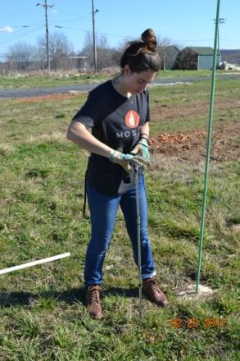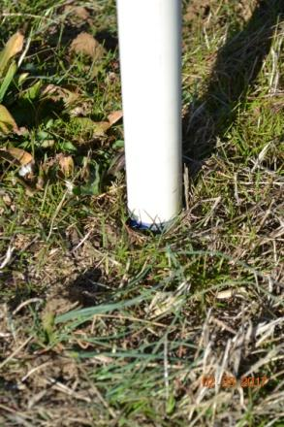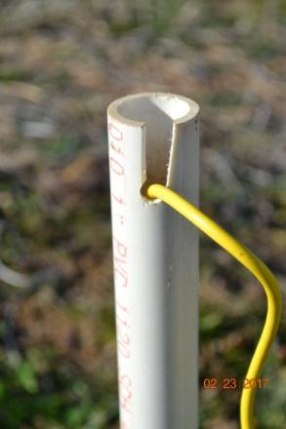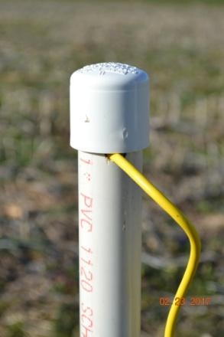

*Installation of TDR310S Sensor*

1. Slip the gasket down the pipe until it is flush with the soil surface. The rubber gasket is to divert water from the pipe and nearby soil to reduce side wall flow.

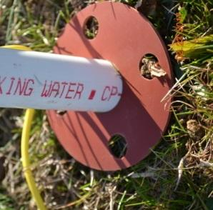

*Rubber Gasket on TDR310S*

1. Repeat steps 2 and 3 for the other two sensors and their depths.
2. The CS655 soil water sensor is installed under the decomposition bag #5 horizontally, 5 cm below the soil surface. Use a hand trowel to excavate a rectangular pit for the sensor. Reserve the soil removed from the pit off to the side (a piece of plastic sheeting or cardboard is helpful). Use the hand hoe and mallet to cut a straight wall on one narrow end of the pit. Measure the depth in several places to be sure it is slightly greater than 2 inches. Level the bottom with the hand hoe.

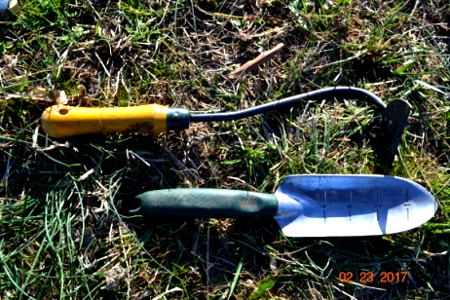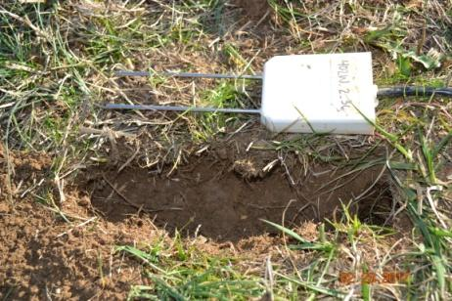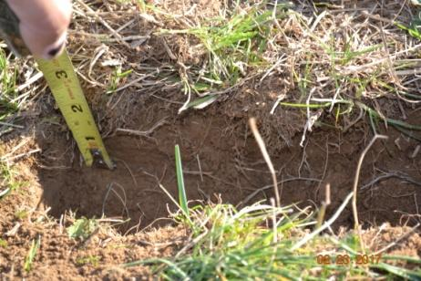

*CS655 Installation Part I*

1. Place the sensor inside the pit, and holding the probes straight, push the sensor into the side wall. Be careful to not bend or splay the probes. Fill in the pit with the soil you removed.

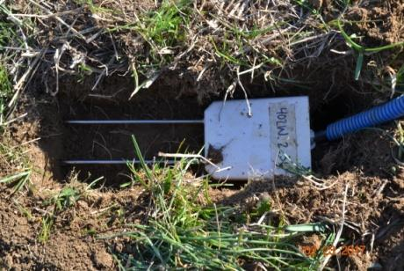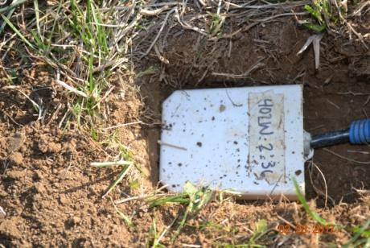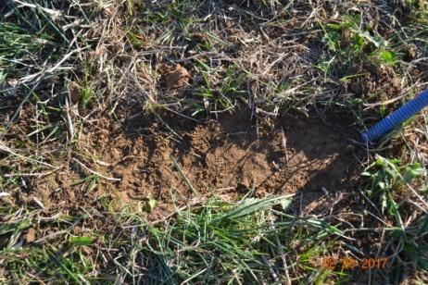

*CS655 Installation Part II*

1. Place the temperature sensor on the soil under the litter bag that is will be removed last from the field.
2. Seal the clamps and the cables with putty.

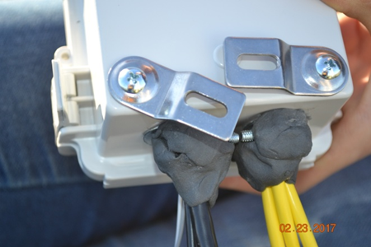

*Cable Clamps Sealed with Putty*

Placement of the Gateway in the field is of utmost importance to its successful operation. The most important factor to consider is line-of-sight. For the Nodes to communicate with the Gateway they must be within “line-of-sight” which means you should be able to see one from the other either with the naked eye or binoculars. Obstructions like hills or buildings will block the radio transmissions though plant structures like corn or trees should not interfere much.

The Gateway enclosure can be easily mounted to a pipe using cable ties. The pipe should be inserted at least two feet into the ground for stability and the enclosure mounted at about five feet (or higher) above the ground. The solar panel should be mounted near the top of the pipe.

The SLA battery should be housed in the battery box with the strap tightly in place. Desiccant packs inside the box are recommended. Placing the box near the pipe or tying it to the pipe helps prevent the cable getting pulled by animals or people walking by the Gateway.